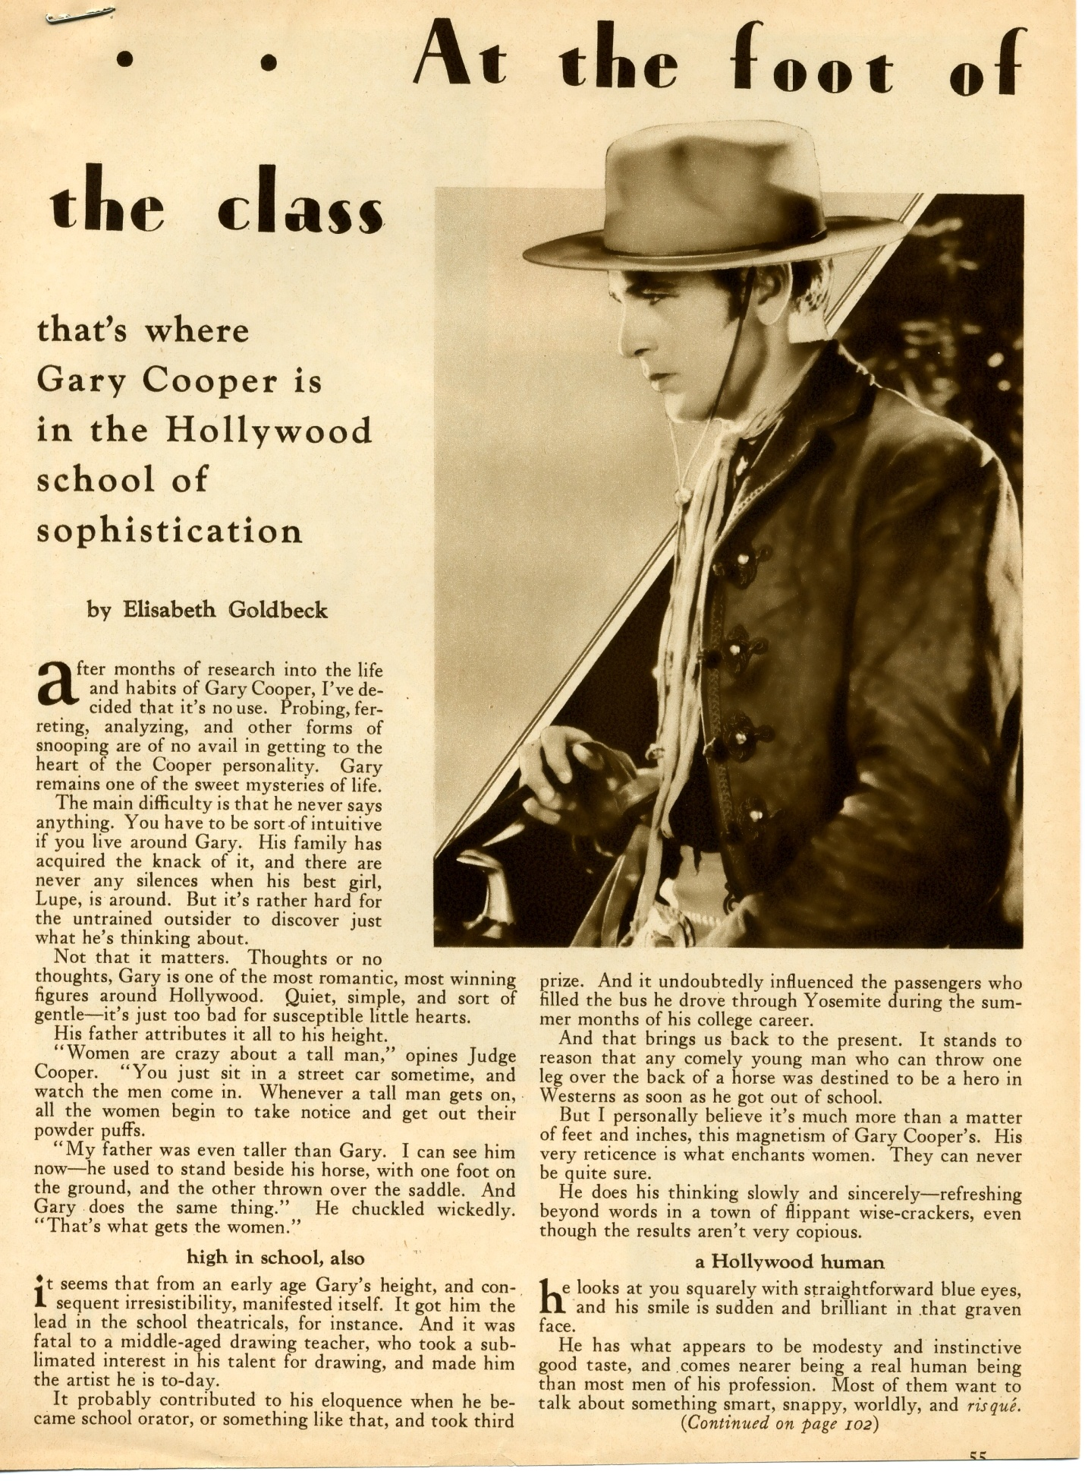
Here’s the part that was cut off:
Judge Cooper is also responsible for the information that Gary is sensitive, very affectionate around the house, that his modesty is unassumed, and that he’s rather domestic. Gary is not without humor, by any means. In fact, he made a personal appearance at a theater in Los Angeles recently, and simply brought down the house with his brusque and homely wit. The manager was running around in circles, hysterically announcing that he’d found another Will Rogers. In short, Gary is what he seems. If as The Virginian he stirs your emotions, don’t let them be bridled by the fear that it’s all a delusion. After watching him on the screen, I assure you, you know as much about him as you would after talking to him for a few hours.

