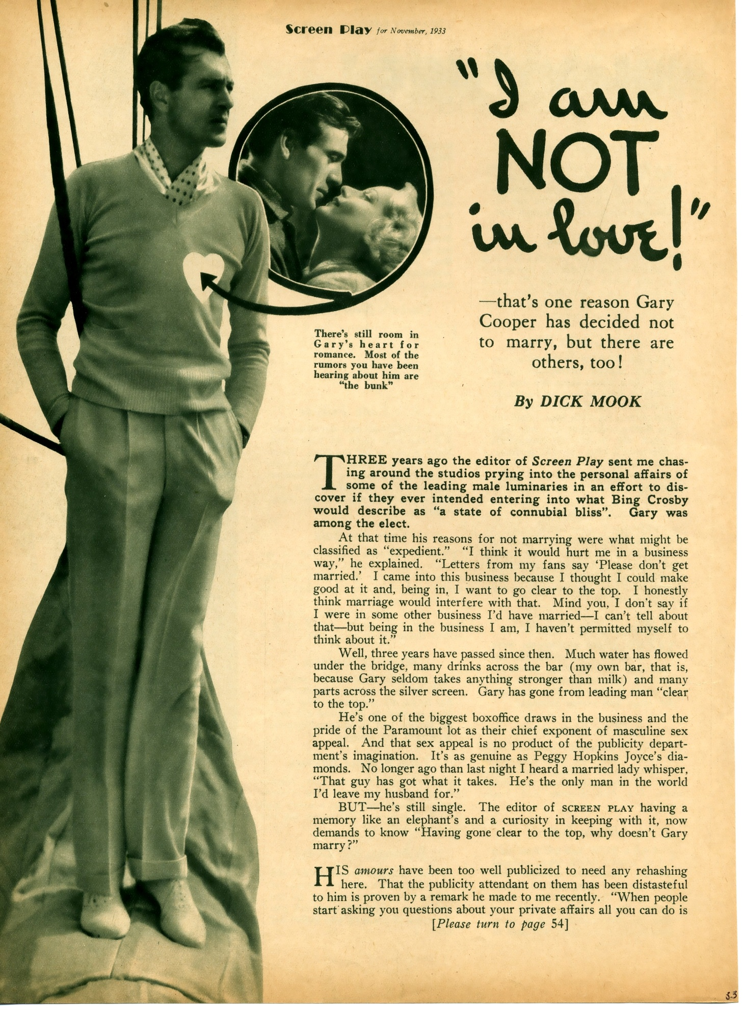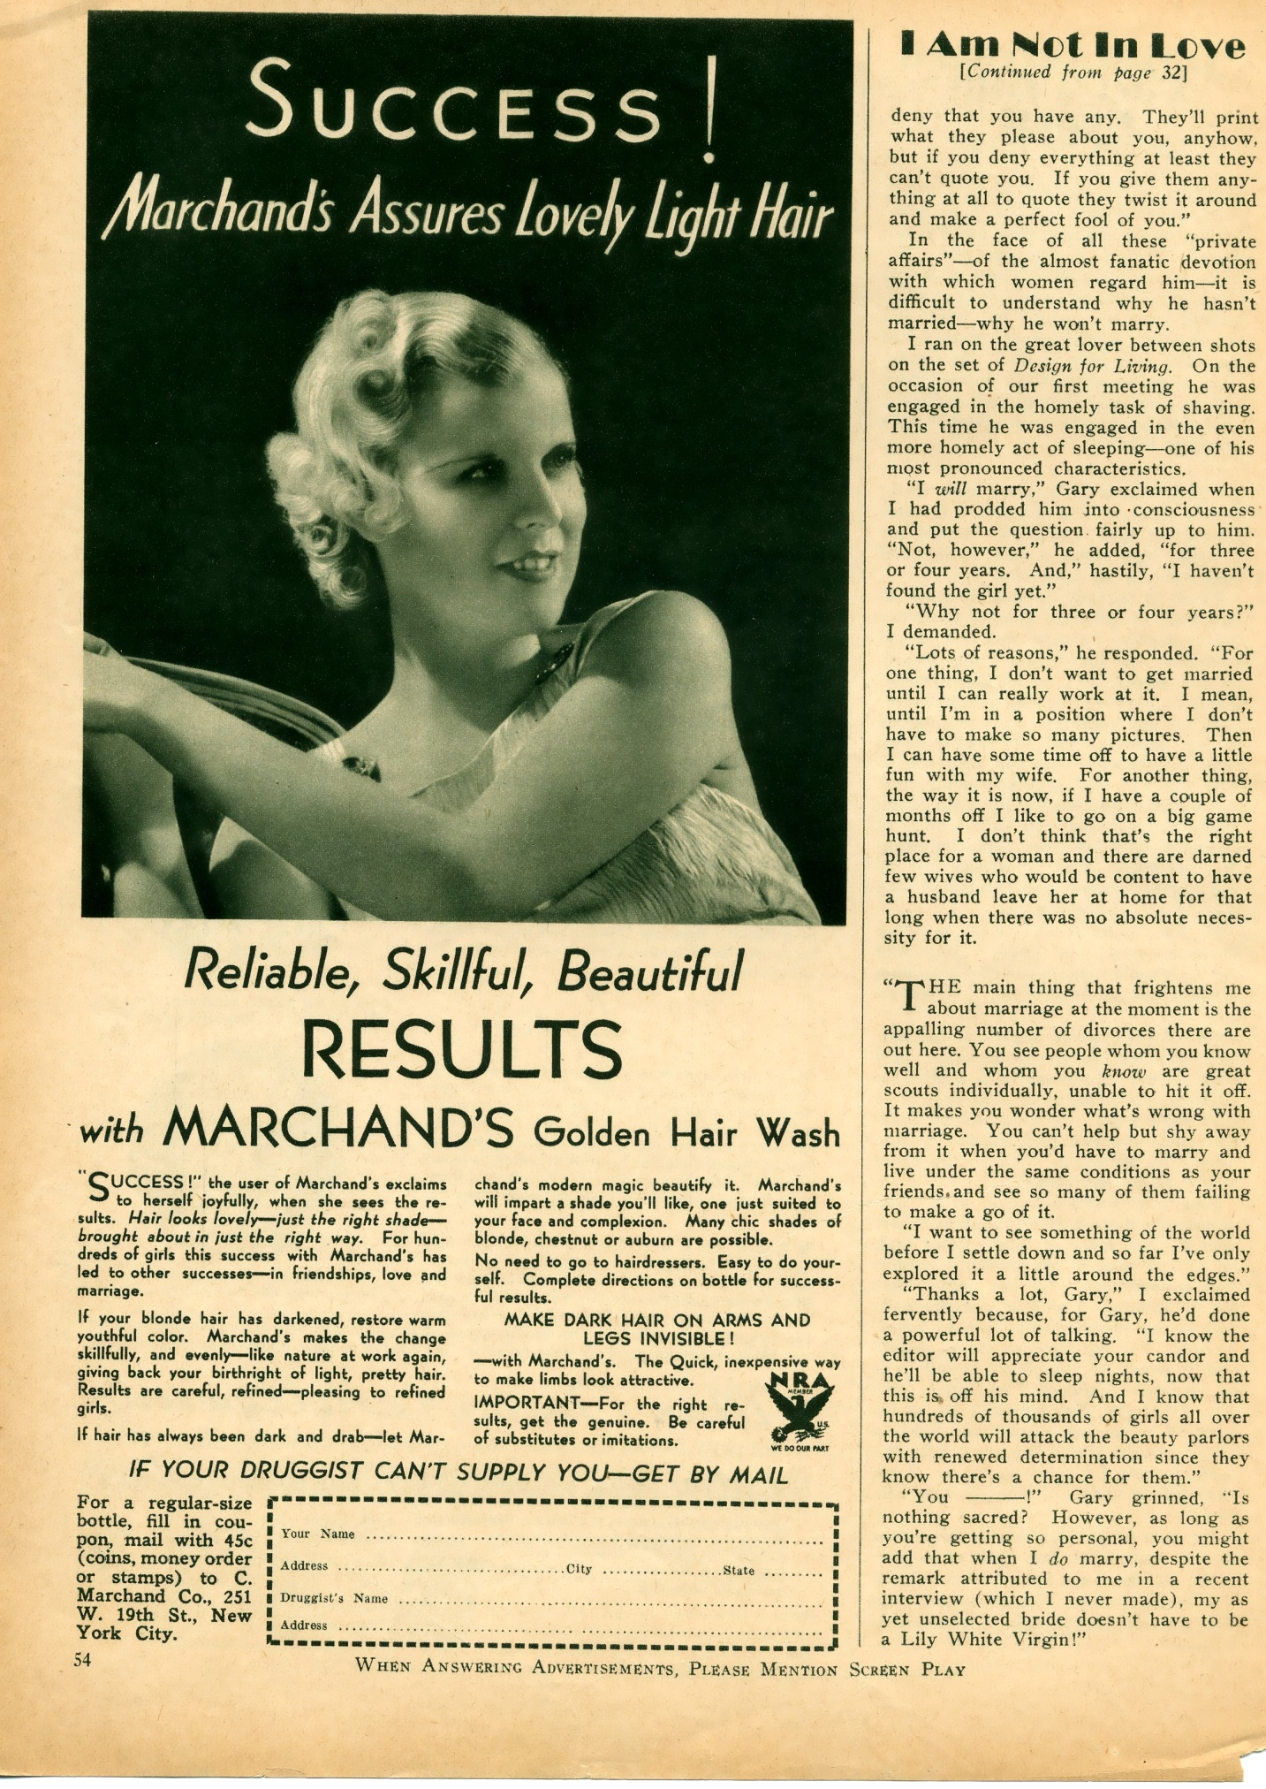
Gary’s last remark here about being misquoted as wanting a lily white virgin refers the article titled “Gary’s Lily White Bride – Jun 1933” also posted here.

